
are
St Aloysius’ College
Year 9 5.3 Term 3 Mathematics Assessment
Tuesday 18th September 2018

NAME: ……………………………………………………
TEACHER: ADA JWL/SRO GON IMO
Time allowed: 40 minutes
Total Marks: 54

Instructions:
• Approved calculators may be used.
• All necessary working is to be shown.
• Marks may be deducted for careless or poorly arranged work.

Indices and Surds 26 marks

1. Simplify fully: (give your answer in index form with positive indices where appropriate)

Questions | Answer | Marks
- 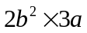 |  | 1
- 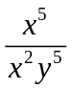 |  | 1
- 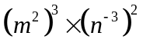 |  | 2
- 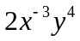 |  | 1
(e) 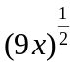 |  | 1
(f) 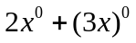 |  | 1
(g) 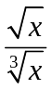 |  | 2
(h) 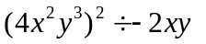 |  | 1

2. Solve for x:

- 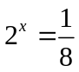 1

- 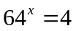
1

- 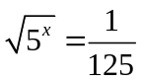 2

3. Write these numbers in scientific notation:

(a) 123 000 1

(b) 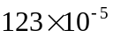
1

4. Simplify the following:

(a) 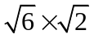 1

(b) 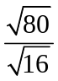 1

(c) 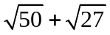 1

5. Simplify 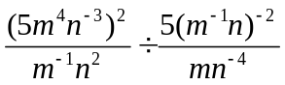 3

- Three billion (3 000 000 000) cells die in your body each minute. 2
Write down in index form how many cells die in 2000 seconds.

- Given that 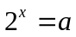 , express 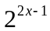 in terms of a. 2

St Aloysius’ College
Year 9 5.3 Term 3 Mathematics Assessment
Tuesday 18th September 2018

NAME: ……………………………………………………
TEACHER: ADA JWL/SRO GON IMO

Quadratic expressions and algebraic fractions 28 marks

1. Expand the following:

- 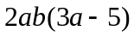 1

- 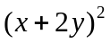 1

2. Factorise the following:

- 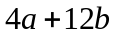 1

- 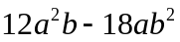 1

- 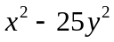 1

- 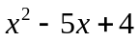 2

- 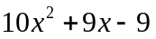 2

3. Simplify the following:
(a) 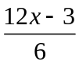 1

(b) 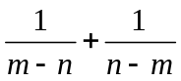 1

(c) 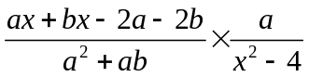 3

(d) 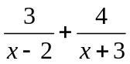 3

4. Solve for x:

- 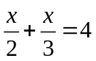 2

- 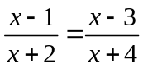 3

5. If one side of a square is increased by 5 cm and another is decreased by 5 cm, a rectangle is
formed whose area is 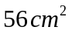 . Find the side of the original square. 3

6. Write a rule for the number of ‘s’ squares in this pattern of ‘t’ tiles 1

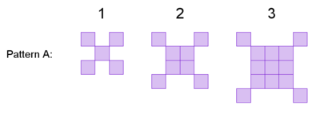

S =
__________________________

7. Find the simplest expression for this sum. 2

__________________________

End of Assessment

